Padlet answers
Schengen Agreement

- What were the aims of the Schengen Agreement?

The Schengen Agreement, signed on 14 June 1985, is a treaty that led most of the European countries towards the abolishment of their national borders, to build a Europe without borders known as the “Schengen Area”. Signed in Luxemburg, initially by only five EU countries, the agreement remains one of the world’s biggest areas that has ended border control between member countries.

France and Germany are the two pioneering countries that are taking the initial steps towards free movement. On 17 June 1984 these two countries were the first ones to bring about the above mentioned topic within the framework of the European Council in Fontainebleau, where they all agreed to define the conditions required for the free movement of citizens.
As a final point of this journey, what came to be “The Schengen Agreement” - covering the gradual abolishment of the internal borders between countries and an extended control of the external borders - was only signed on 14 June 1985. The Agreement was signed by the following five European countries: France, Germany, Belgium, Luxemburg and The Netherlands in Schengen, a small village in Southern Luxemburg on the river Moselle.

- When did the implementation of the Schengen Area actually start?

The implementation of the Schengen Agreement started in 1995, initially involving seven EU States. Born as an intergovernmental initiative, the developments brought about by the Schengen Agreements have now been incorporated into the body of rules governing the EU. Today, the Schengen Area encompasses most EU States, except for Bulgaria, Croatia, Cyprus, Ireland, Romania and the United Kingdom. However, Bulgaria and Romania are currently in the process of joining the Schengen Area. Of non-EU States, Iceland, Norway, Switzerland and Liechtenstein have joined the Schengen Area.

- What is the procedure for getting a Schengen Visa?

If you want to start the procedure you need:
- A Visa application form.
- Two recent photos.
- A valid passport.
- A round trip reservation or itinerary.
- A travel insurance policy.
- Proof of accommodation.
- A hotel/hostel booking.
- A rental agreement.
- A letter of invitation from the host where you will be staying.
- Proof of financial support.
- A bank account statement.
- A sponsorship Letter
- A combination of your bank account statement and a letter of sponsorship.
- Proof of paid visa fee.

4. What is the standard duration of a Schengen Visa?

The standard duration of a Schengen Visa is 90 days in any period of 180 days.

5. What are the consequences of overstaying in the Schengen Zone?

If you overstay your welcome in the Schengen area you could face the following consequences:

- DEPORTATION (if you get caught staying in Europe illegally, you will be deported to your home country) ,
- DIFFICULTIES RETURNING TO THE SCHENGEN ZONE (Even if you return to your home country without any fine or ban, you should know that overstaying will cause you problems the next time you attempt to enter the Schengen Zone.)
- A FINE (This is the highest penalty for overstaying a visa. The fees are applied differently depending on the member state. However, if you are caught after you have illegally remained in the Schengen area for a longer time, not only will you have to pay a but you will also be banned from entering the Schengen Area for an appointed period of time, or even forever.)
- A BAN: this is usually applied to those overstaying and working or engaging in other illegal activities.

6. When does overstaying not have any consequences?

If you are a child, or a person who cannot travel without a caretaker due to illness or disability, then you will probably not face any consequences for overstaying.

7. Are the same penalties applied in all member states?

As there is not a common policy for all Schengen Member States regarding overstaying penalties, each State applies different types of penalties.
Therefore, the consequences of overstaying in a Schengen territory (whether your visa or the permitted 90 days has expired for nationals of the countries under the visa-waiver program), depends a lot on the number of days you have overstayed and the country you get caught in. Germany is known to have the strictest immigration laws in the EU; while Greece is known for applying very high fines to those caught overstaying.

8. How is Passport and Visa security granted?

The security of these documents is essential. To improve it, the EU has decided to equip them with advanced security features and biometrics (facial images and fingerprints). This set of measures helps to fight against the falsification and counterfeiting of travel documents, while biometric identifiers establish a reliable link between the document and its holder. For example, according to EU law, passports must incorporate a storage medium (a chip) that contains the holder's facial image and fingerprints. A European Image Archiving System has also been set up to facilitate exchanges of information between EU States. It provides for the rapid validation, storage and exchange of information on genuine and false documents by computerised means.

Dublin Regulation

1. What is the so-called Dublin system?

The Dublin Regulation established a Europe wide finger printing database for unauthorised entrants to the EU.
The Dublin Regulation aims to rapidly determine the member state responsible and provides for the transfer of an asylum seeker to that member state.
Usually the responsible member state will be the state through which the asylum seeker first entered the EU.

2. When were the various agreements signed?

15 June 1990 agreements were signed in Dublin
1 September 1997 entry into force for twelve states
October 1997/ 1998 a further three countries entered
2006 Denmark also finally entered
2013 the III entered into force

3. What are the main objectives of the Dublin III Regulation?

The Dublin system was never designed to achieve solidarity and the fair sharing of responsibility: its main purpose from the very beginning was assign responsibility for processing an asylum application to a single Member State.
The Dublin III Regulation identifies the EU country responsible for examining an asylum application, by using a hierarchy of criteria such as family unity, possession of residence documents or visas, irregular entry or stay, and visa-waived entry. In practice, however, the most frequently applied criterion is the irregular entry, meaning that the Member State through which the asylum-seeker first entered the EU is responsible for examining his or her asylum claim.

4. What are the limits of this policy?

In the context of our project on legal assistance to asylum seekers we deal with hundreds of cases of asylum seekers who are in Greece and have applied for family reunification under the DUBLIN III Regulation.

5. When was the Dublin Regulation partially suspended?

On 23 June 2015.

6. Which countries have raised the main objections?

Denmark.

Humanitarian NGOs

1. Who are the humanitarian NGOs operating in the Mediterranean Sea?
2. Which events have spurred their operations?
3. How are the NGOs funded?

None other than thousands of citizens from Europe and beyond: businesses, local authorities, and churches. The grassroots missions of recent years have relied on incessant crowd funding. Donations are raised online – on platforms such as Better Place or directly from the NGO websites – during charity events or thanks to big donors: Richard Gere or Pep Guardiola for Proactive Open Arms, winners of TV quiz games for Sea-Eye, ship-owners who sell their assets for reduced prices. There are 35,000 people “behind” Proactive Open Arms, with its three small ships; 12,000 people have sponsored Sea-Watch’s two vessels and the Moonrise aircraft; and 14,000 people support the Aquarius and 1,500 have funded Sea-Eye.

4. What is “WATCH THE MED”?

Watch the Mediterranean Sea is an online mapping platform to monitor the deaths and violations of migrants' rights at the maritime borders of the EU. The WatchTheMed project was initiated as part of the 2012 Boats4People campaign in the Central Mediterranean. Today the project further involves a wide network of organisations, activists and researchers.

5. Whose help does it rely on?

Through transnational cooperation with migrants’ rights organisations, activists, researchers, migrants, seafarers active in, around and beyond the Mediterranean and the use of new mapping technologies, WatchTheMed aims to document the deaths and violations that are the structural product of the militarized Southern European border regime. Through the accounts of survivors and witnesses, but also the analysis of ocean currents, winds, mobile phone data and satellite imagery, it is possible to determine in which Search and Rescue zone, jurisdictions and operational areas an incident occurred – as well as showing other boats who were in the vicinity of those in distress.

EU Operations

1. What are the main objectives of all EU Operations in the Mediterranean Sea?

- To save lives at sea;
- To strengthen border control;
- To disrupt the business model of traffickers and human smugglers.

2. Describe objectives, scope, cost, duration and results of the:

MARE NOSTRUM OPERATION

Operation Mare Nostrum was a year-long naval and air operation started by the Italian government on October 18, 2013.

The operation's search and rescue component is claimed by advocacy groups like the European Council on Refugees and Exiles to have saved thousands of lives.

Fenice (F 557) is one of the eight corvettes of Minerva class with the role of surveillance of fisheries; from November 2013 it took part in the Operation Mare Nostrum rescuing the boats of illegal immigrants coming from North Africa.

The European Commission provided financial support for the operation with €1.8 million from the External Borders Fund. Mare Nostrum was operated by the Italian Navy and saw ships operating near the coast of Libya.

The operation was politically unpopular and extremely costly for just one EU state. The Italian government had requested additional funds in order to continue the operation, from the other EU member states, but they did not offer the requested support.

The operation ended on 31 October 2014 and was superseded by Frontex's Operation Triton, which operates a smaller search and rescue capability. Unlike Mare Nostrum, Operation Triton focused on border protection rather than search and rescue, and operates closer to the Italian coast. The termination of Mare Nostrum has been criticized as a cause of the increased death rate among migrants to Europe in the Mediterranean, which increased tenfold between 2014 and 2015. Two major migrant shipwreck disasters which together killed more than 1000 people within the span of a week in April 2015 led to calls to renew the operation.

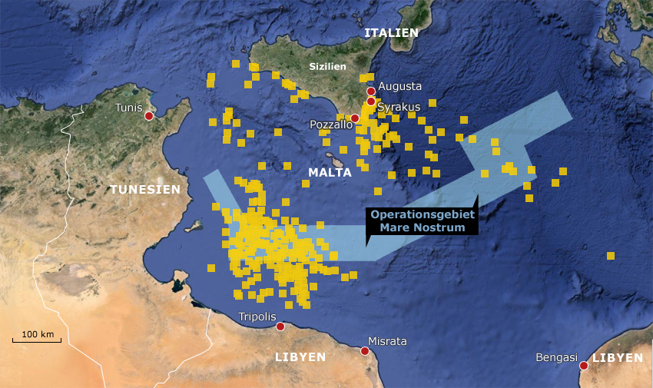

3. Describe objectives, scope, cost, duration and results of the subsequent:

FRONTEX OPERATIONS: TRITON+POSEIDON

FRONTEX

Frontex, the European Border and Coast Guard Agency, was established in 2005 by the European Union. It was tasked with border control in the Schengen Area and is primarily responsible for coordinating border control efforts.

It still remains the task of each member state to control its own borders, but Frontex ensures that they all do so with the same high standard of efficiency. Their main tasks, according to the council, are to:

- coordinate cooperation between member states in external border management.
- assist member states in the training of national border guards.
- carry out risk analyses.
- carry out research relevant for the control and surveillance of external borders.
- help member states requiring technical and operational assistance at external borders.
- provide member states with the necessary support in organising joint return operations.

To enable the agency to carry out its tasks, its budget would be gradually increased from the €143 million originally planned for 2015 up to €238 million in 2016, €281 million in 2017, and will reach €322 million (about US$350 million) in 2020. The staff of the agency would gradually increase from 402 members in 2016 to 1,000 by 2020.[

TRITON

Operation Triton is a border security operation conducted by Frontex, the European Union's border security agency. Operation Triton supports Italy with border control, surveillance and search and rescue in the Central Mediterranean. Its operational area covers the territorial waters of Italy as well as parts of the search and rescue zones of Italy and Malta, stretching 138 nautical miles south of Sicily. On numerous occasions, Frontex vessels and aircrafts have also been redirected by the Italian Coast Guard to assist migrants in distress in areas far away from the operational area of Triton. The operation, under Italian control, began on 1 November 2014 and involves voluntary contributions from 15 other European nations (both states and non-members). Current voluntary contributors to Operation Triton are Croatia, Iceland, Finland, Norway, Sweden, Germany, the Netherlands, France, Spain, Portugal, Austria, Switzerland, Romania, Poland, Lithuania and Malta. The operation was undertaken after Italy ended Operation Mare Nostrum, since it became too costly. Its budget is estimated at €2.9 million per month.

POSEIDON

Operation Poseidon provides Greece with technical assistance with the goal of strengthening its border surveillance, its ability to save lives at sea and its registration and identification capacities. Frontex also assists the Greek authorities in carrying out returns and readmissions. Its operational area covers the Greek sea borders with Turkey and the Greek islands.
"Joint Operation Poseidon" began in 2006, after Greece asked for surveillance by Frontex of the country's sea and land borders between the EU-member Greece and Turkey. The Joint Operation is divided into two branches, the Poseidon Sea Operation which oversees the sea borders of the EU with Turkey in the Mediterranean and Aegean seas, and the Poseidon Land Operation which oversees the south-eastern land border of the EU with Turkey on the Evros river. The operation turned permanent and has been expanded subsequently in the year 2011. In 2015 this operation was replaced by Poseidon Rapid Intervention.
4. Describe objectives, scope, cost, duration and results of

OPERATION SOPHIA

Operation Sophia, European Union Naval Force Mediterranean (EU NAVFOR Med) is a military operation of the European Union that was established as a consequence of the April 2015 Libya migrant shipwrecks with the aim of neutralising established refugee smuggling routes in the Mediterranean.
The operation’s core mandate is to identify, capture and dispose of vessels and enabling assets used or suspected of being used by migrant smugglers or traffickers.
Operation Sophia is named after a baby that was born on board a German frigate in the autumn of 2015 – according to Federica Mogherini to “honour the lives of the people we save, the lives of people we want to protect, and to pass a message to the world that fighting the traffickers and criminal networks is a way to protect human life”.

On 20 June 2016, the Council of the European Union extended Operation Sophia’s mandate reinforcing it by adding two supporting tasks: The length of the Operation may be continuously renewed by the Council.

From October 2016, SOPHIA is fully involved in the training of the Libyan Coastguard and Navy; the aim of the training is to improve security of the Libyan territorial waters and the Libyan Coastguard and Navy ability to perform the duties in their territorial waters, with a strong focus on respect of human rights, including minors and women’s rights, and the correct handling of migrants in occasion of search and rescue activities to save lives at sea.

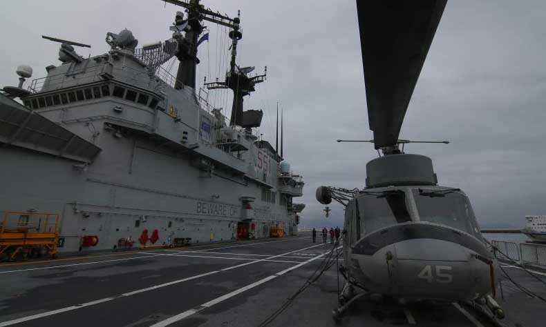

EU-Turkey Agreement

1. When was the EU-TURKEY Agreement signed?

On 18 March 2016
2. Who was involved?

The European Council and Turkey
3. What is the aim of this agreement?
The aim of this agreement is to make it easier for migrants to travel from Turkey to the other European countries. The asylum process would also become easier for both migrants and the other countries especially for Turkey, who will not have to take on the burden of all these people on her own.
4. What are the KEY POINTS of the agreement?
- Turkey's EU accession negotiations
- Additional financial aid
- Visa liberalization process
- One for one
- Returns
5. What are the positive results of this agreement?
THERE ARE NO POSITIVE RESULTS.
NEGATIVE EFFECTS:
- TURKEY HAS USED A LOT OF MONEY
- THEY DO NOT GO BACK!

